# Requesting Authorization for a Service Provider

Step  
1

**In the Appointments section of your Home page, click the case number hyperlink**

Figure : Attorney Home Page

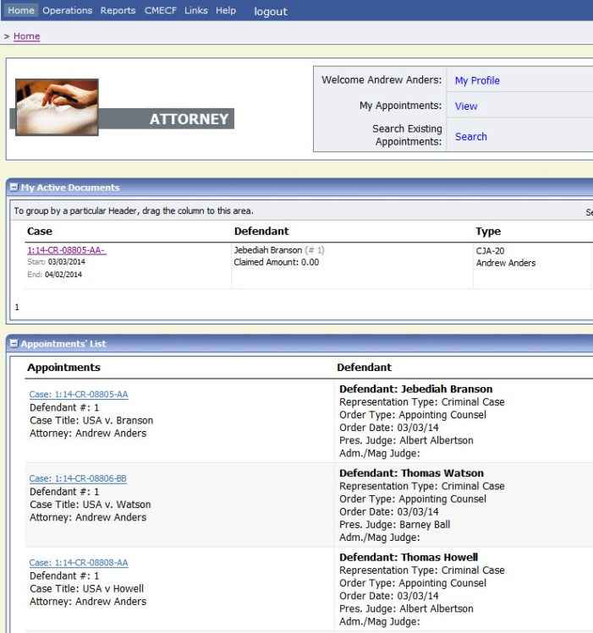

You will be taken to the **Appointment Info** page.

Step  
2

**On the Appointment Info screen, click the AUTH Create link on the left panel.**

Figure : The Appointment Info screen

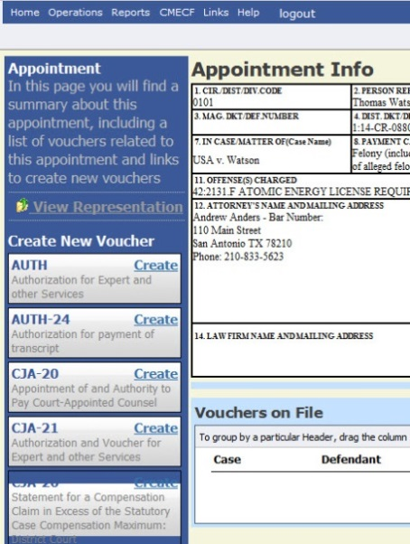

Step  
3

**Fill in the information requested for the Authorization.**

Enter information in the **Estimated Amount**, **Basis of Estimate**, and **Description** fields, then from the **Service Type** drop-down menu, select the applicable service type.

Figure : Authorization Basic Info

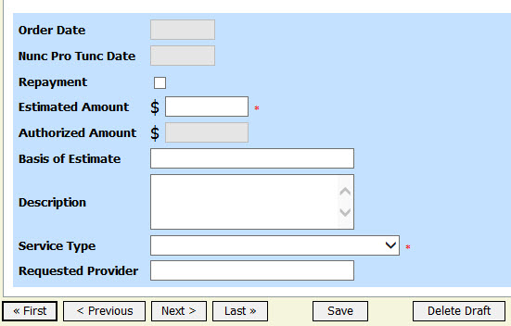

## Notes:

* You may attach multiple supporting documents in the **Documents** tab. You will be able to include a description for each document as you load it.

Step  
4

**Submit your Authorization Request.**

Figure : Authorization Request Confirmation Tab

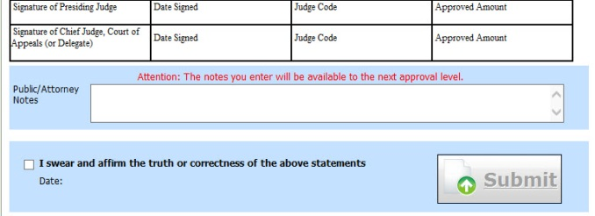

## Notes:

* You may add notes to your submission on the **Submit** tab. Select the "I swear..." check box (the date will automatically update to the current date) and click **Submit.**